Market Segmentation Analysis of

Electric Vehicles Market in India

Contributors

Vaibhav Kale

Date : 14Th July 2023

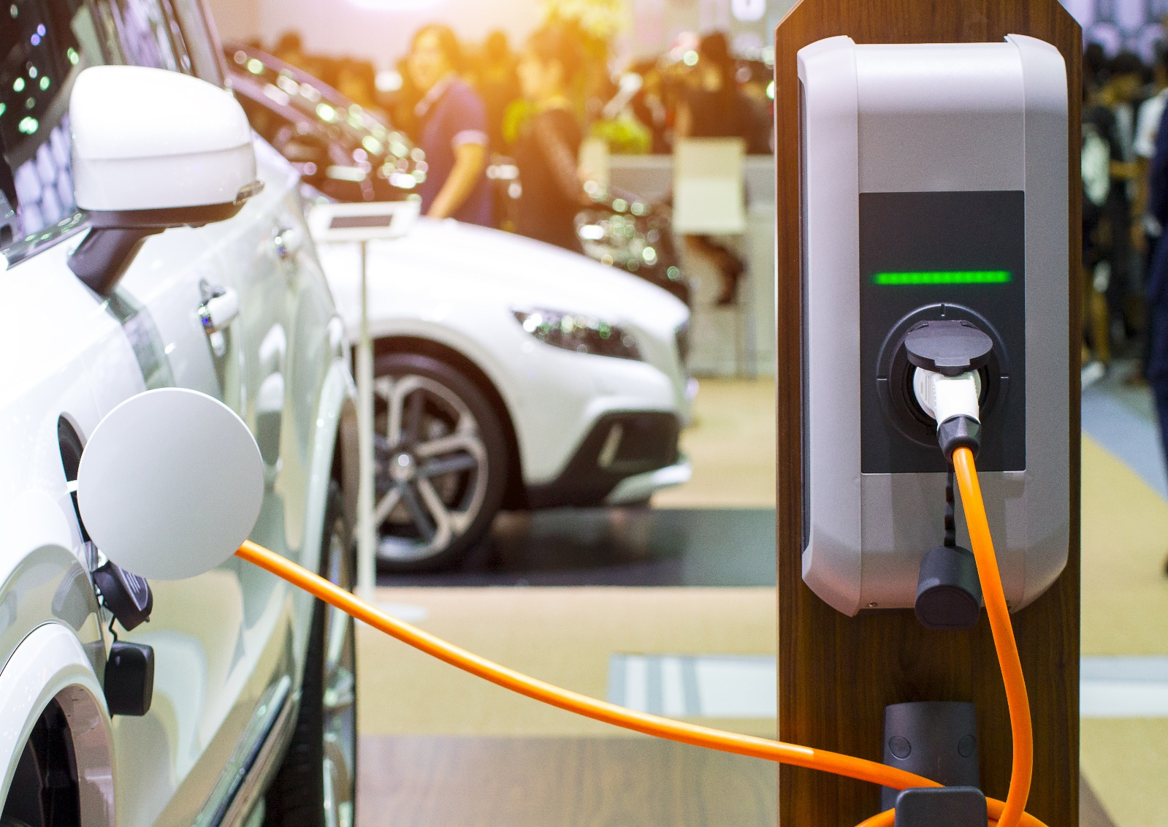

**Problem Statement**

You are a team working under an Electric Vehicle Startup. The Startup is still deciding in which vehicle/customer space it will be develop its EVs. You have to analyse the Electric Vehicle market in India using Segmentation analysis and come up with a feasible strategy to enter the market, targeting the segments most likely to use Electric vehicles. (CUSTOMER/VEHICLE/B2B) SEGMENTS: Apart from Geographic, Demographic, Psychographic, Behavioral segments, teams can consider different CATEGORY of Segments for the Segmentation Tasks, based on AVAILABILITY OF DATA. Market Segmentation comes with wide scope of possibility and Segments created can change based on different datasets collected.

**What is Electric Vehicle?**

An EV is a shortened acronym for an electric vehicle. EVs are vehicles that are either partially or fully powered on electric power. Electric vehicles have low running costs as they have less moving parts for maintaining and also very environmentally friendly as they use little or no fossil fuels (petrol or diesel).

While some EVs used lead acid or nickel metal hydride batteries, the standard for

modern battery electric vehicles is now considered to be lithium ion batteries as

they have a greater longevity and are excellent at retaining energy, with a self- discharge rate of just 5% per month. Despite this improved efficiency, there are still challenges with these batteries as they can experience thermal runaway, which have, for example, caused fires or explosions in the Tesla model S, although efforts have been made to improve the safety of these batteries.

**Working principle**

An electric vehicle works on a basic principle of science: conversion of energy.

Electrical energy is converted into mechanical energy. There is a motor used in

the electrical system to carry on this duty of conversion. Motors can be of various

types.

**Market Overview**

The Indian electric vehicles (EV) market size was valued at USD 8,674.45 million in 2022 and is projected to reach a value of USD 23,514.54 million by 2031 , registering a CAGR of 23.47% during the forecast period 2023-2031.

An Electric Vehicle (EV), otherwise battery electric vehicle (BEV), in simple terms, is a vehicle that runs on electric motors. EV is a possible alternative to the current automobile that uses gasoline and diesel, which emits a considerable amount of C02, which is harmful to nature. Throughout the forecast period, market growth is anticipated to be fueled by the attractive incentives being offered by the Indian government on the production and purchase of electric vehicles to promote the adoption of electric vehicles. An important factor driving the electric vehicle market in India is the post- lockdown sale of pure and hybrid electric vehicles. The government's strict greenhouse gas (GHG) emission norms, such as the Bharat Stage (BS) VI emission standards adopted by India's Ministry of Road Transport and Highways (MoRTH), are also anticipated to contribute to the market's expansion significantly.

Electric Vehicles depend on one or more electric motors for propulsion. These vehicles are not just eco-friendly but cost- effective options than petrol-based vehicles. They usually run on lithium-ion batteries, which have exceptional longevity and good power of retaining energy. Governments worldwide are making efforts to increase the use of these vehicles to curb pollution. The

Indian EV market is divided by vehicle type, power source type battery, and region.

**Market Dynamics**

**A Rise in Urbanization to Benefit the Electric Vehicle Market**

By 2030, it is anticipated that 50% of the population will live in urban areas. India is one of the emerging economies, and there are many villages and underdeveloped regions in India. Like metropolitan cities such as Mumbai, Pune,

New Delhi, Kolkata, Bengaluru, etc., the government is trying to evolve the rural cities by developing improved infrastructure, transport, healthcare, and more. With these facilities comes the introduction of advanced technologies, and this idea of urbanization invites the need for EVs.

The need to control the emission of ozone-depleting gases, reduce fuel imports, and the ever-increasing energy cost are other driving factors of the EV market. Around 98 cities have been nominated for the Smart City Mission 2015. It is an urban development program launched by the Government of India. Many cities under this mission have already embraced the use of these vehicles. The demand from these cities will spike in the years to come.

**Indian Electric Vehicles (EV) Market Restraints**

High Costs of EVs

Electric vehicles are expensive as compared to conventional transport options. This is because of the expensive, compact-sized lithium batteries they operate on. These batteries are almost equal to the fuel prices in India. These

high costs are also because of India's lack of lithium-ion battery manufacturing units.

India heavily relies on imports for raw materials to make these batteries, and lithium and cobalt are the minerals India imports primarily from China. Moreover, many EV companies in India function with less than 50% localization.

Hence, they cannot avail themselves of the benefits and subsidies under the FAME (Faster Manufacturing and Adoption of Hybrid and Electric Vehicles) phase two. All these factors contribute to the increased prices of these vehicles, holding back the market.

**Data Collection**

1. Kaggle

**Data Pre-processing**

Reading Data

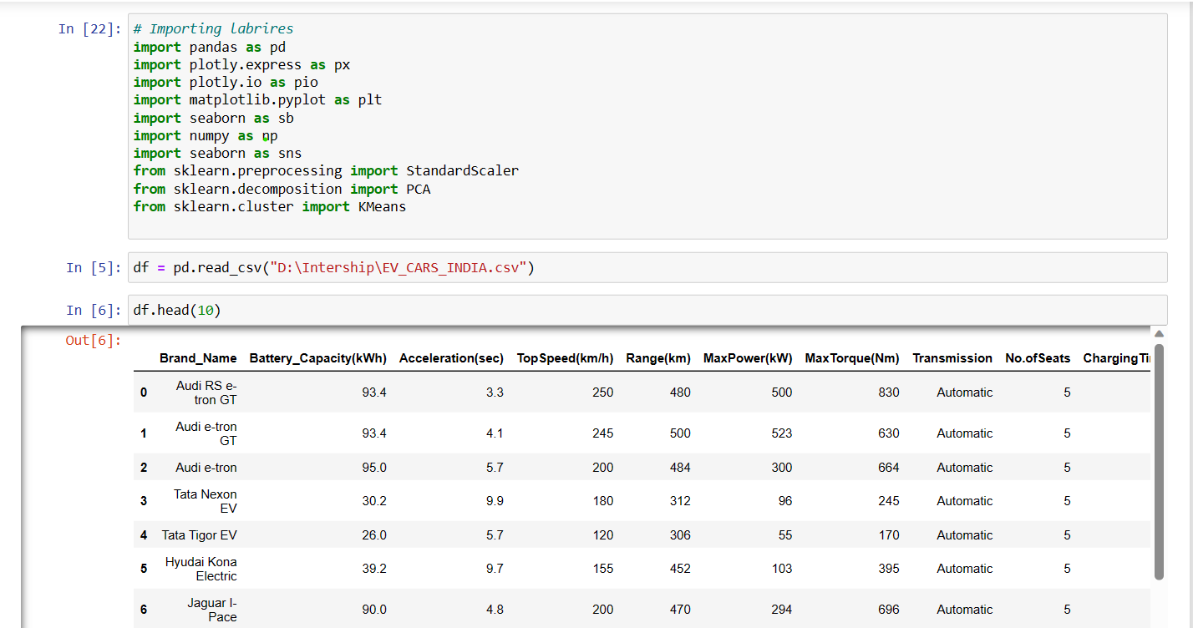

Checking for Null values in the dataset

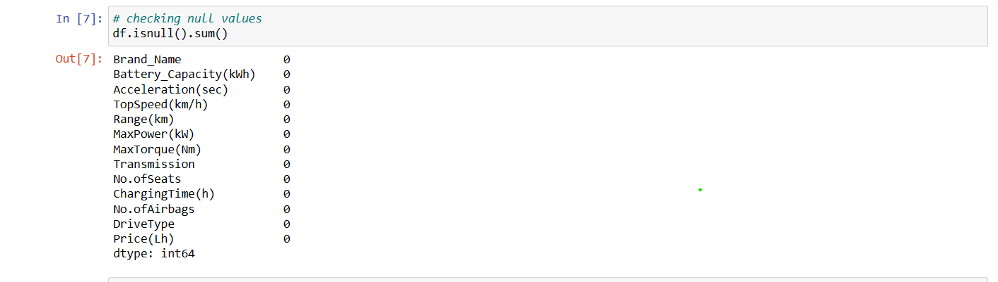

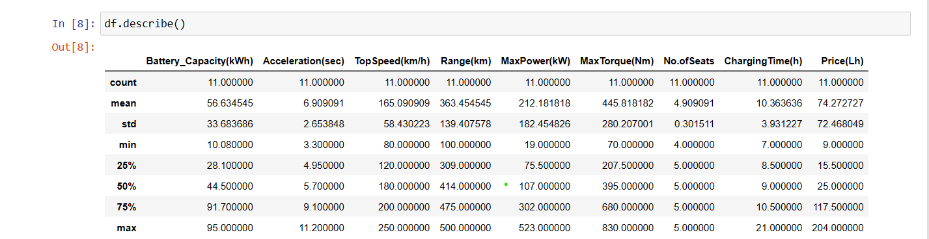

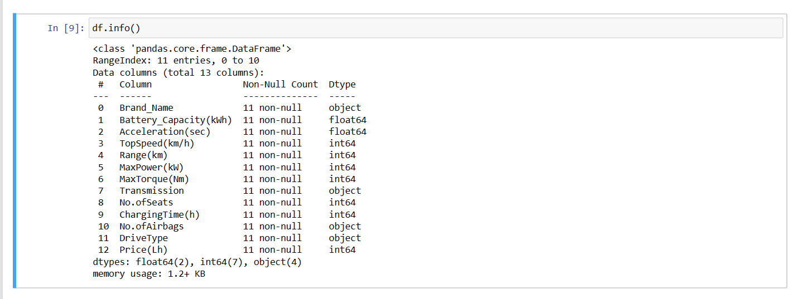

**EDA**

An Exploratory Data Analysis or EDA is a thorough examination meant to uncover the underlying structure of a data set and is important for a company because it exposes trends, patterns, and relationships that are not readily apparent.

We analysed our dataset using univariate (analyse data over a single variable/column from a dataset), bivariate (analyse data by taking two variables/columns into consideration from a dataset) and multivariable (analyse data by taking more than two variables/columns into consideration from a dataset) analysis.

The bar graph below shows the car data. We can see that we have maximum speed in ‘Audi RS e-tron GT’ and minimum speed in ‘Mahindra e2op4/p6’

Comparison of cars in our dataset

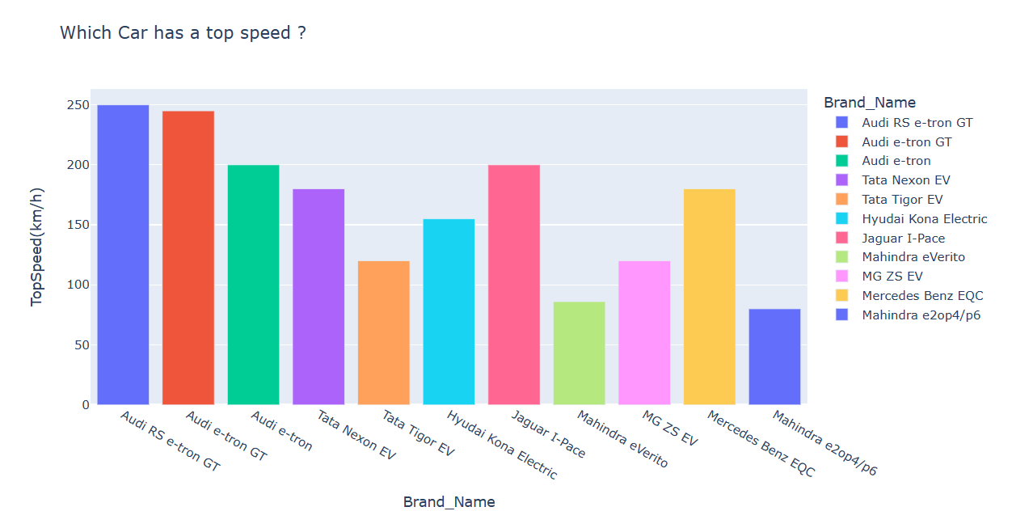

The below bar graph show that which car has highest accelaration

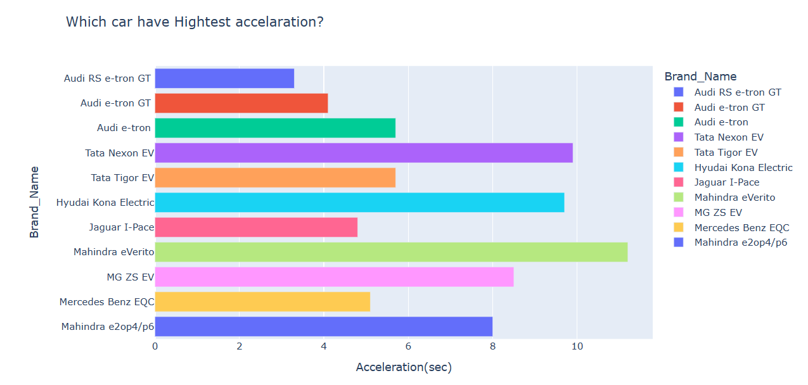

We can see that ‘Audi e-tron’ have maximum battery capacity and ‘Mahindra e2op4/p6’ have minimum battery capacity

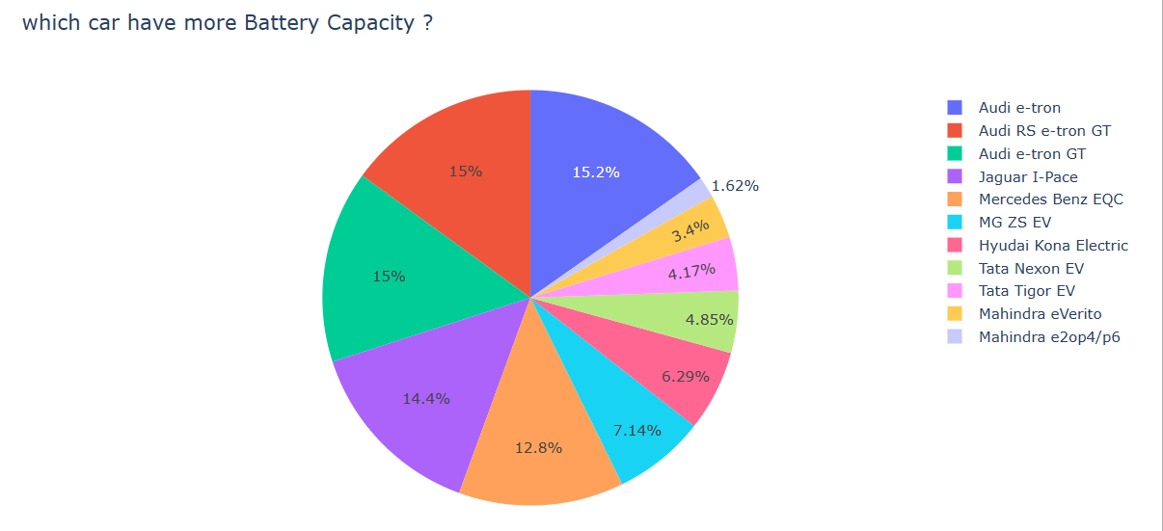

Below graph show which car has a Max power

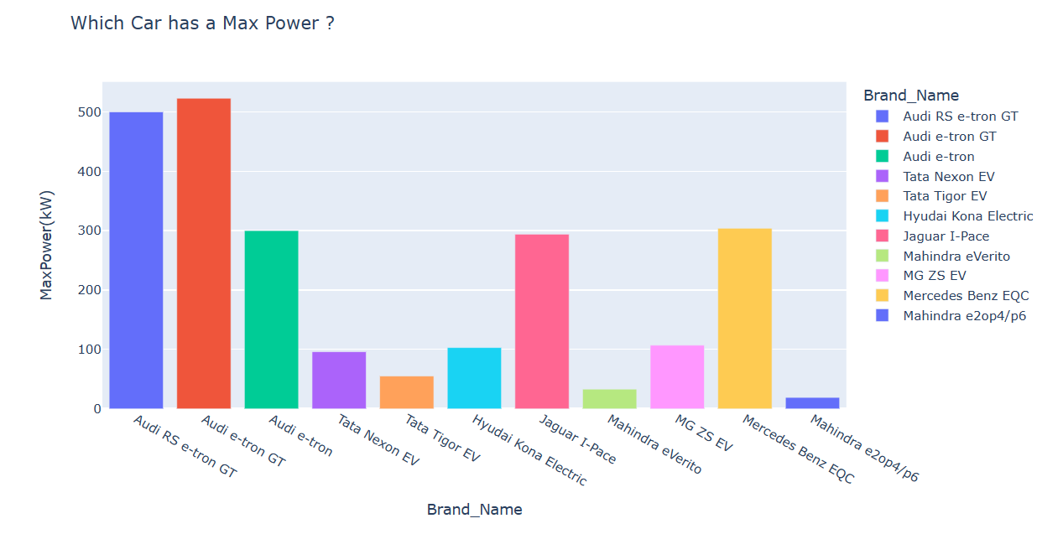

Below graph show that which Drive Type is more expensive

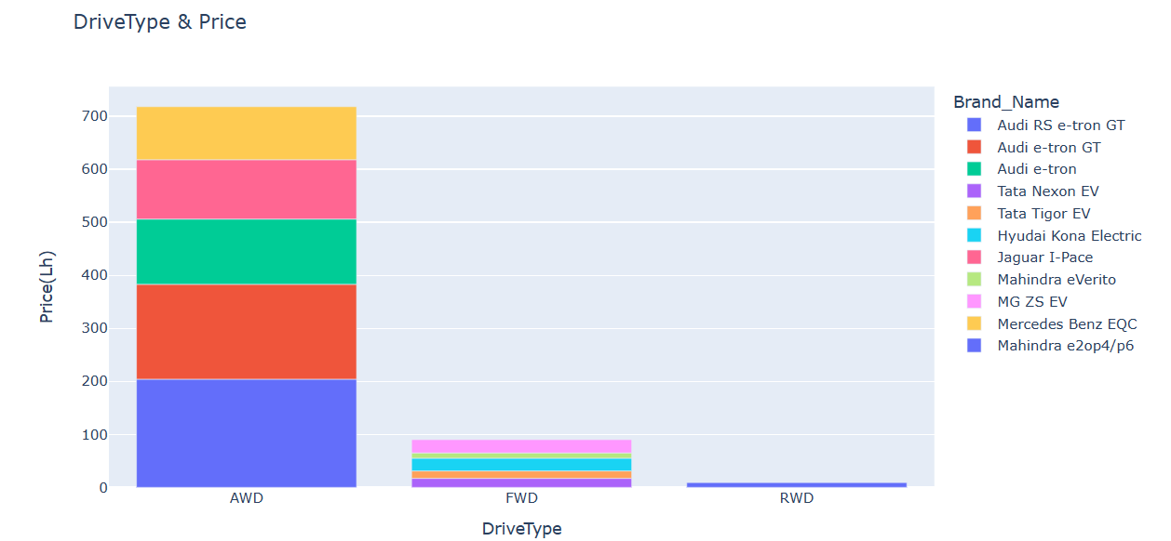

Below graph show that which car has fast charging

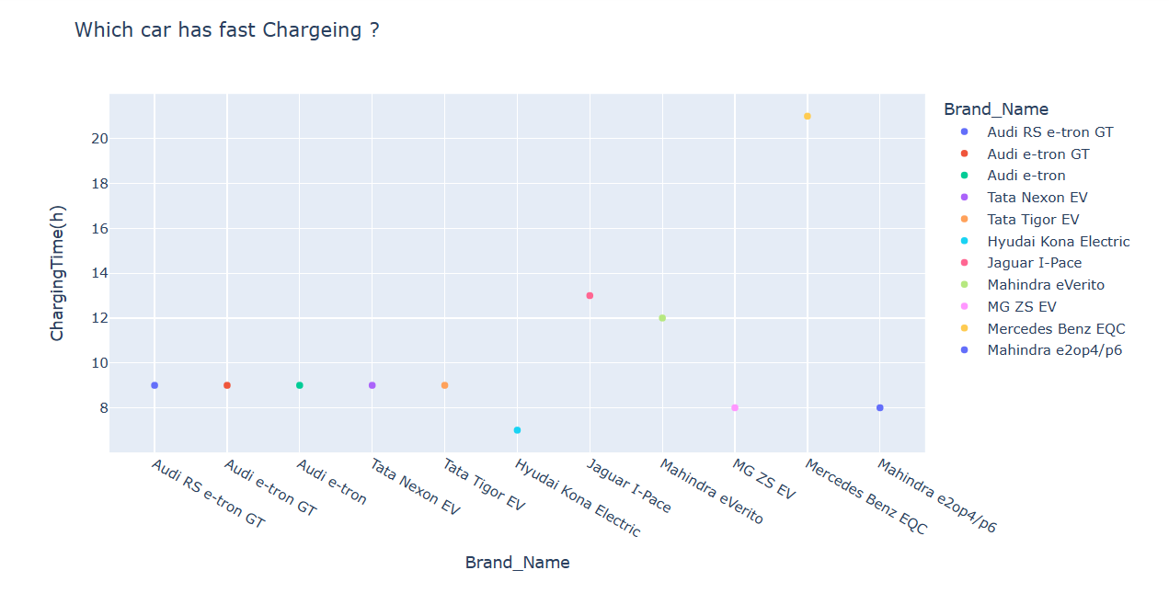

Below pie chart show that which car is more expensive

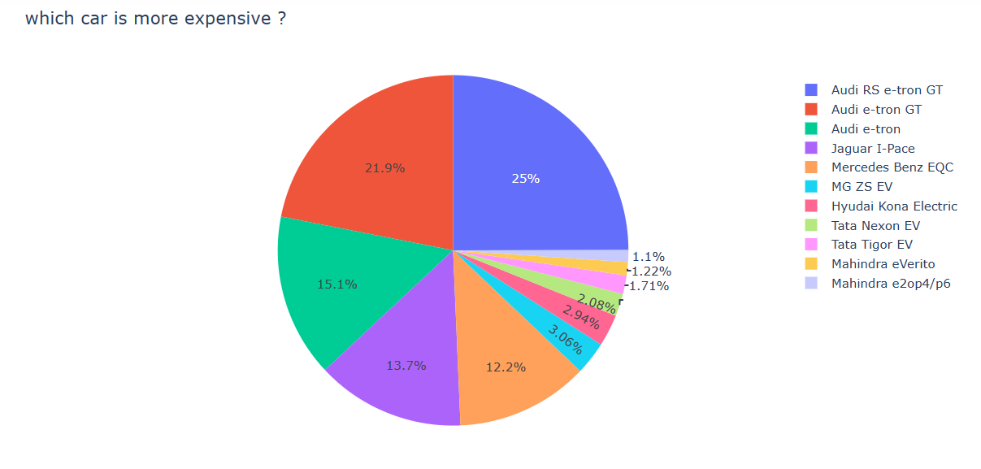

Below graph show the relation between Range and Charging Time

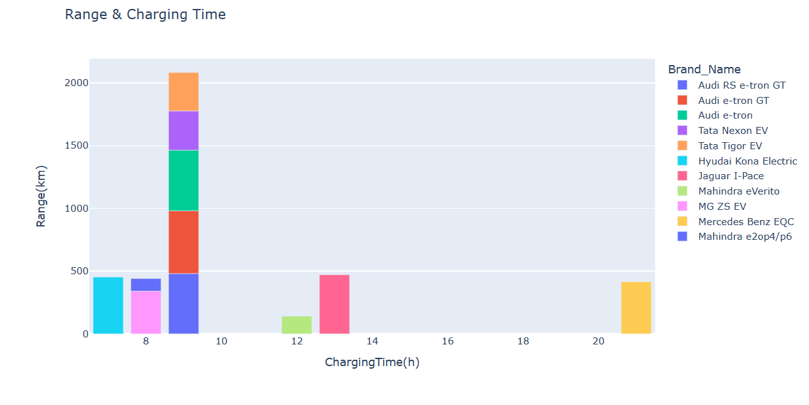

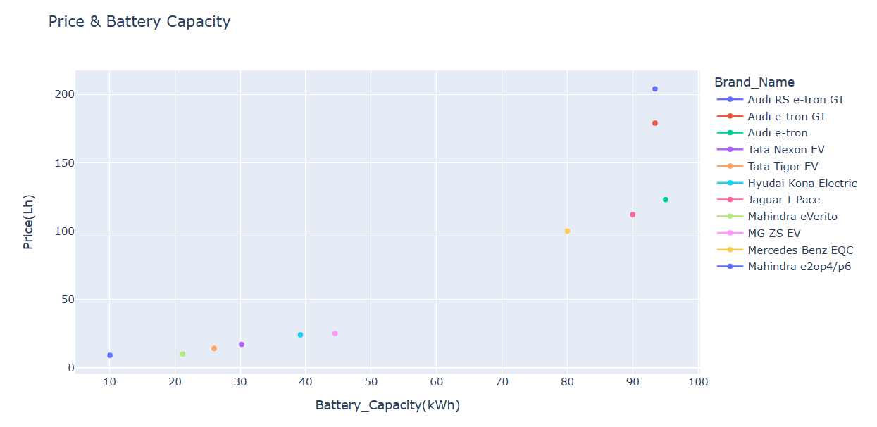

**Segment Extraction**

Linear regression is one of the easiest and most popular Machine Learning algorithms. It is a statistical method that is used for predictive analysis. Linear regression makes predictions for continuous/real or numeric variables such as **Battery Capacity , Top Speed, Range, Max Power, Price,** etc.

Linear regression algorithm shows a linear relationship between a dependent (y) and one or more independent (y) variables, hence called as linear regression. Since linear regression shows the linear relationship, which means it finds how the value of the dependent variable is changing according to the value of the independent variable.

The Indian Electric Vehicle (EV) Market is categorized into Top Speed, Battery Capacity, Range , Max Powe, Price

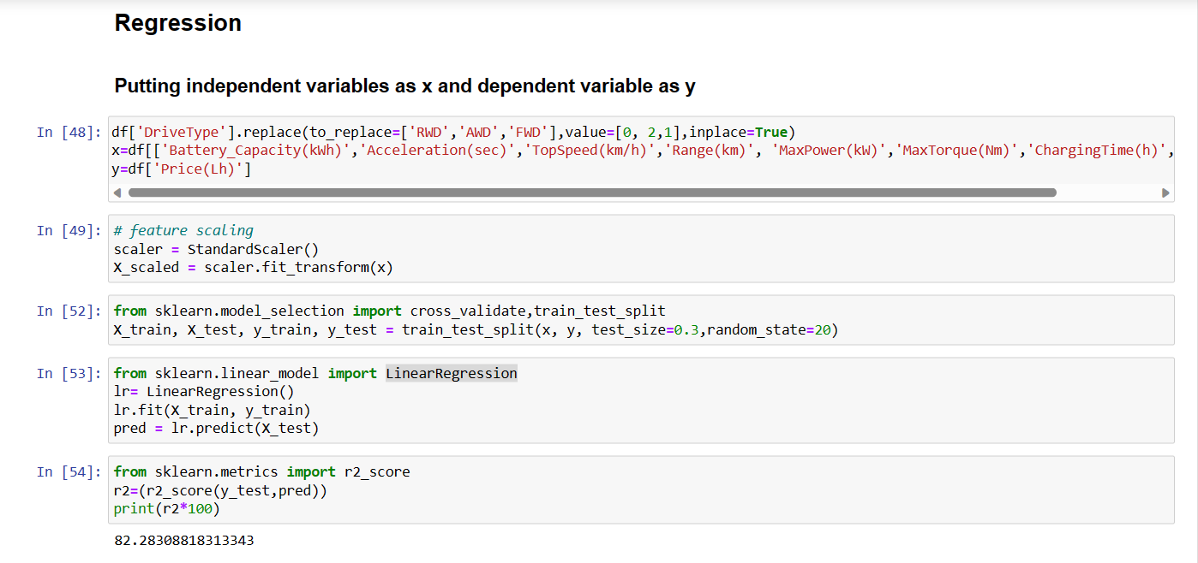

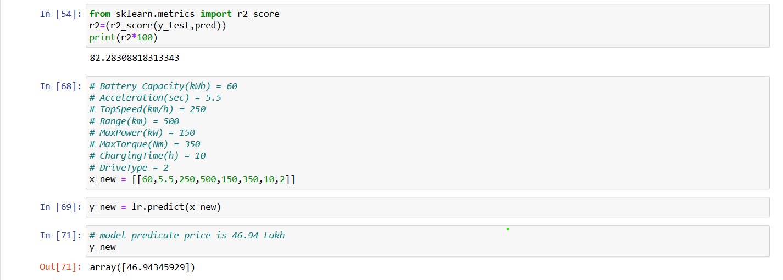

**Profiling potential segments**

**Behavioural Segmentation** : Segmenting the market based on customer behavior aspects such as what price range customers usually buy in , what kind of specifications customers look for in their cars

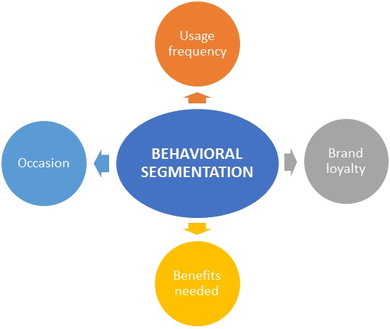

**Psychographic Segmentation:**

Segmenting the market based on psychological parameters, such as the likes and dislikes of customers, whether they prefer comfort over speed of a vehicle, etc.

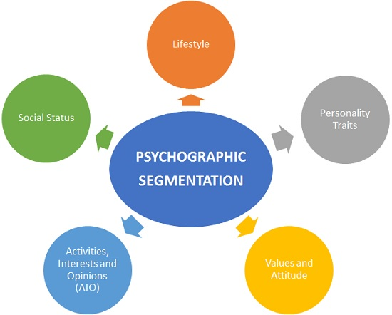

Behavioural Factor :

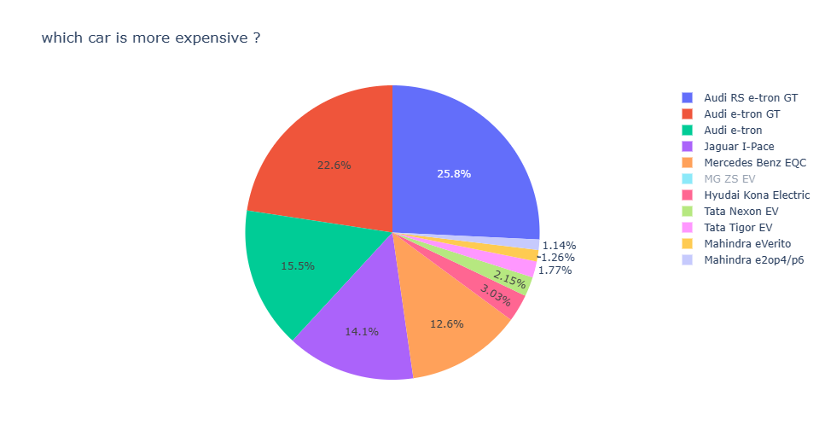

**Target Segments**

Based on the analysis, the target segment can be narrowed down to EVs having:

* **Psychographic factors** such as Comfort and Value for Money
* **Behavioural factors** such as good Acceleration and viable Price range

In conclusion, the target segment should comprise of EVs having Acceleration of 7.5-10 sec, Battery Capacity of 75 kWh , Top Speed is 200 ,and have maximum power ,High in Comfort and Value for Money ratings, have a Price range of 20-30 Lakhs.

**Customizing the market mix**

The marketing mix helps enable the growth of the business in the automotive industry. A company's marketing mix or 4Ps (Product, Place, Promotion, and Price) specify the approaches and strategies that address the target market, based on the details of the marketing plan. The company's aim is to maximize sales and improve market presence. With a strong position in the market, However, strategic decision-makers must allow for flexibility in relevant strategies.

The automotive market has various opportunities for the growth, such as opportunities for products that integrate advanced computing technologies. However, the company technologies its business environment. Managers can use the SWOT Analysis to determine appropriate adjustments in the marketing mix or 4Ps to deal with these threats and opportunities.

**Product Mix**

This aspect of the marketing mix pertains to the outputs of the business. Each product line represents a group of outputs or products. The set of all the product lines is called the product mix. the product mix shows limited business diversification. Nonetheless, the company offers a wide variety of products, such as different brands, types, and models of automobiles.

1. Automobiles
2. Automobile parts
3. Commercial vehicles
4. Financial services

**Prices and Pricing Strategies**

The setting of price points and price ranges for the company's products is the main concern in this aspect of the marketing mix. Pricing affects the perceived value of brands and products, and influences sales in price-sensitive markets. the pricing strategies for its automotive products are as

follows:

l. Market-oriented pricing strategy

2. Premium pricing strategy

**Promotional Mix**

Promotional activities are considered in this aspect of marketing mix of4Ps. These activities are also known as marketing communications tactics. The combination of these tactics is called a promotional mix or marketing communications mix the following promotional activities are used, arranged according to significance in the automotive business:

1 Advertising (primary)

1. Direct marketing
2. Personal selling
3. Sales promotion
4. Public relations

**Place/Distribution**

In this aspect of marketing mix or 4Ps, the virtual or physical locations of transactions are considered. Such locations are significant because they enable the company to reach target customers in specific markets, while also allowing customers to access information and products available from the automotive business. The following places are used in the distribution of products and

services:

1. Official websites
2. Dealerships
3. Automotive shows and exhibits

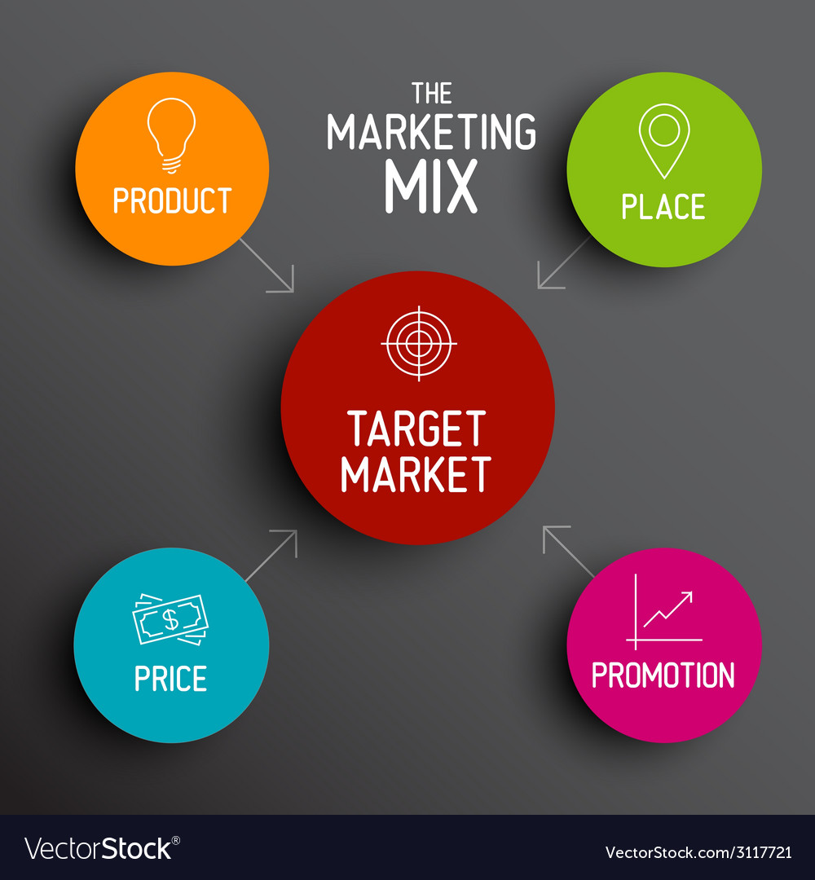

**Potential Sales in Early Market**

Purchasing a vehicle is one of those life accomplishments that top nearly everyone's bucket list. The majority of the customers have a family. For such folks there are a variety of reasons, including market and schooling. Whether you prefer a modernized urban loft or a sprawling suburban home with a white picket fence, most of us hope to find a vehicle that feels like it was made specifically for our family. Here is where our insights come in to assist such people to find a best vehicle at the best-fixed price according to the area and several other factors.

Some of the key points required to focus for the development of EV in India are:

1. Retrofitting conversion of Public Transport (Bus), Taxi and Three-Wheeler (Auto) to PHEV: This is one of the key requirements to move towards sustainable transportation. It will not only balance emissions but also reduce the load on infrastructure requirement.
2. Government Incentives: Another key factor for XEV market to lift up will be identification of strategic incentives for electric vehicles. This will increase adoption rate and decrease main element barrier of the price of electric vehicles to customers. The incentive can be subsidy scheme for electric vehicles bridging gap price between the conventional and electric vehicle in similar performance range. e.g., if the cost of internal combustion engine car is INR 5 lakh and that of the electric vehicle is INR 6.5 lakh, the government can intend to offer discount or subsidy of the differential cost. In addition, benefit of Discount on VAT /Discount on Registration/Discount on Toll Plaza to motivate sell of EV can be planned.
3. Charging Infrastructure: Charging infrastructure development will occur with the development of XEV market. However, motivation can be provided by developing grid-connected charging station with the moderate tariff, promotion to standalone renewable (solar/wind) charging station, add on facility at petrol pump and bus stops for charging and state transport charging stations and permitting the development of private renewable charging stations.
4. Electrical Propulsion System (EPS): Currently no Indian manufacturer provide electrical propulsion system (EPS) manufactured in India, even REVA has a tie-up with Italy for EPS. Hence support and positive atmosphere build-up in manufacturers in one of the critical tasks. Development of clear policies for supporting the growth of supply, manufacturing, and recycling of propulsion system. Power electronics converter and motor technology development are feasible as technology base is available in India, however currently used cost-effective Li-ion technology of battery development is challenging task as the majority of lithium stock are available in China and USA. In addition, battery replacement/swapping can be one of the promising and viable options in India.
5. Development of Skilled Manpower: Consideration of safety and advanced technology involved, development of certified skilled technician and professionals is one of the requirements.
6. Awareness: Awareness on benefits of XEV and promotions of the government can play a significant role in development. It can be done with the help of extensive advertisement at airport/bus station/cinema halls/government offices/public places using banners/hoardings, use of print media-newspaper/magazines/periodicals, digital media/radio/e media-internet, TV shows, expert talks, providing micro-funding for projects/conferences in schools, colleges and industry, supplying R & D grants to research scholar/institute industry. The promotional highlights for the consumer can be:

* Good for the environment/Lowers Emission: Electric vehicles emit lower levels of a range of air pollutants, e.g. nitrogen oxides, particulate matter and greenhouse gases(e.g. carbon dioxide-C02) than vehicles using conventional petrol and diesel engines
* Cheaper to run/improve Fuel Economy: As electricity is cheaper than petrol or diesel, the running costs of EVs are less than conventional vehicles.
* Less Life Cycle Cost.
* Perfect for urban use: Reduced levels of pollution and noise make EVs ideal for inner city and urban use.

**Most Optimal Market Segment**

There are many EV manufacturing companies in the country like Hero Electric, Tata Motors, At her Energy, Ashok Leyland, Hyundai Kona Electric, etc. Tesla has also arrived; the demand will get higher & higher since it is automotive so the investments and policies and all that would be bigger but it will take some time to perfectly settle in India. The following are the key insights of the project:

* The electric vehicle industry has not done that much good due to the devastating hit of the Covid outbreak but it will take a huge jump in upcoming years.
* The use of EVs will be game-changing in terms of environment, air, noise pollution-free, post- electric, and much more.
* The company should plan to establish local operations in India either by partnering with a local company or by setting up its own manufacturing/ development unit, potentially combined with imports of specific components.
* The company would expect to further grow in India, underpinned by a growing commercial fleet market for two-wheelers and three-wheelers especially for last km delivery urban freight services. The company must see opportunities across the supply chain in the battery, EV component and charging infrastructure segments including the machinery and equipment needed for establishing manufacturing plants, training and provision of skilled workforce etc.
* The company should start their business from Metro Cities in India and then after considerable business expand to other cities of the same state of the Metro Cities. This will help the company to expand easily as they will be having a prior knowledge of business from Metro Cities and Network of Supply chain will be easy for the company as the time goes in business.

GitHub link : https://github.com/vaibhavkale07/Market-Segmentation-Analysis-on-Electric-Vehicle-in-India